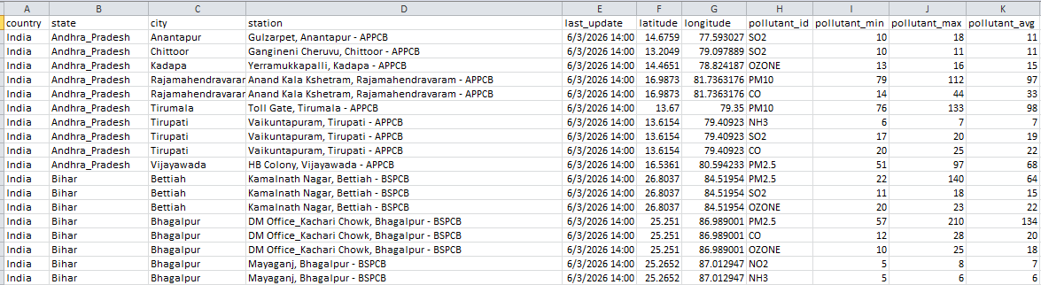

Data modelling:

CREATE TABLE location (
location_id INT PRIMARY KEY AUTO_INCREMENT,
country VARCHAR(50),
state VARCHAR(100),
city VARCHAR(100),
station VARCHAR(200),
latitude FLOAT,
longitude FLOAT
);

CREATE TABLE pollutant (
pollutant_id VARCHAR(20) PRIMARY KEY,

);

CREATE TABLE AQI(
record_id INT PRIMARY KEY AUTO_INCREMENT,
location_id INT,
pollutant_id VARCHAR(20),
last_update DATETIME,
pollutant_min FLOAT,
pollutant_max FLOAT,
pollutant_avg FLOAT,

FOREIGN KEY (location_id) REFERENCES location(location_id),
FOREIGN KEY (pollutant_id) REFERENCES pollutant(pollutant_id)
);

